**To: Mr. Anies Baswedan, Governor of Jakarta Province**

**Subject: Recommendation for Bus School Program Targeting Schools with Over 20-Minute Walking Distance from Nearest Bus Stops**

**Date: November 13, 2023**

**Introduction**

Over the past decade, Jakarta has significantly expanded its public transportation network, with a focus on increasing the number of bus stops and routes, particularly in densely populated areas. This effort has played a crucial role in narrowing the socio-economic gap. However, it is imperative for the government to consider schools as a pivotal factor when determining bus routes and stops. Empirical evidence suggests a regressive impact on schools with low accessibility, leading to increased commuting time for students, which, in turn, affects attendance, dropout rates, and overall academic performance[1].

An additional concern is the rising likelihood of students resorting to private transportation, such as motorcycles. The lax enforcement of age restrictions for driving licenses has created a situation in which obtaining a license legally is perceived as challenging. Consequently, individuals may feel compelled to engage in bribery, contributing to increased risks of traffic-related injuries or fatalities[2]. Ensuring proper accessibility for every school is therefore a crucial target for the provincial government[3].

In conclusion, this analysis aims to address the materiality of this issue and determine where attention should be focused first to implement a first hanging solution.

**Methodology**

Our primary goal was to identify schools in Jakarta facing accessibility issues, where students need to walk more than 20 minutes to and from the nearest bus stop. To achieve this, we gathered data from various sources, including Jakarta Open Street Map and Jakarta Open Data. Additionally, we obtained generic data, such as administrative boundary polygons, from the ArcGIS portal. The spatial analysis was conducted using ArcGIS Pro software, with visualization accomplished using the R 'ggplot2' package. The final output from ArcGIS was a CSV format, readable in R.

The final CSV contains school-level data as the unit of observation, encompassing variables related to our key interest, including the administrative location of the school, school-age population served by each school, and the nearest distance to the bus stop in meters. The distance to the bus stop was then categorized into four groups for easier analysis in the Results section. By integrating young population data in each Kelurahan, our aim was to provide a more comprehensive understanding of the population dynamics surrounding each educational institution.

The visualization phase aimed to comprehend the materiality of the problem and identify areas where the issue might have a more significant impact. This understanding helps determine which cities need to implement solutions more urgently than others.

**Results**

The analysis reveals a concerning scenario, with a significant number of schools facing accessibility challenges. Figure 1 visually represents schools falling within the category of over 20-minute walking distances from the nearest bus stops. Although most schools have less than a 20-minute walking distance, many still require support to reduce inequality.

When examining the data by city, the issue becomes more pronounced in East Jakarta, as illustrated in Figure 2. The East Jakarta city government should prioritize addressing this problem in their public transportation planning. Additionally, Figure 3 demonstrates a correlation between the number of populations and schools in each district. East Jakarta again shows the most critical condition, indicating a need for immediate implementation. This information implies that Jakarta Province may need to focus more on this city, as 7.2% of the young population in Jakarta is experiencing this problem in East Jakarta.

In addition, we also found that approximately 4.89% of the Jakarta population within the age group of 5-17 is adversely affected by prolonged walking distances to schools. If left unaddressed, this issue could negatively impact future economic income in Jakarta and Indonesia.

**Assumptions and Limitations**

Two key assumptions underlie the analysis. First, we assumed a reachable distance by calculating how far one can walk at 5 km/h for 20 minutes, resulting in approximately 1667 meters. Another assumption is that the population served by each school can be proxied by dividing the population in each "Kelurahan" by the number of schools in each "Kelurahan." This assumption is deemed true as school location planning considers population distribution as one of the most important parameters.

One limitation of this research is that the spatial analysis only considers the bus stop located within the Jakarta province administrative boundary. Therefore, there might be a situation where a school, particularly the one close to the boundary, is closer to the bus stop located outside Jakarta province, which cannot be recorded in our spatial analysis. However, this limitation can be deemed negligible since the bus stop outside Jakarta is not well developed and not interconnected with TransJakarta.

**Conclusion**

The findings emphasize the urgency of addressing school accessibility challenges in Jakarta. To enhance well-being and reduce the socio-economic gap, we recommend the implementation of a Bus School Program targeting schools with over a 20-minute walking distance from the nearest bus stops, starting in East Jakarta region. This initiative aligns with broader goals of inclusivity and equitable access to education in Jakarta. Your commitment to improving the lives of Jakarta's residents, especially in the education sector, will undoubtedly contribute to the city's overall development.

We are at your disposal for any additional information or assistance needed to pursue this recommendation further. Thank you for your attention to this matter.

Sincerely,

Rio P. Kaswiyanto

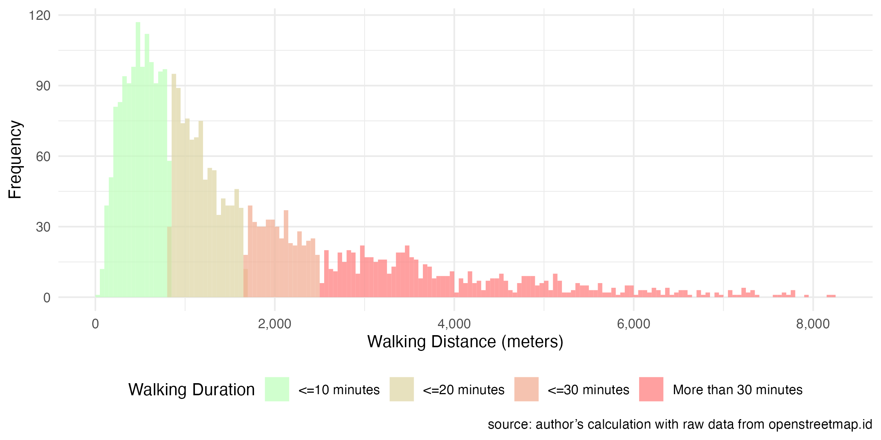

Figure Distribution of Walking Distance to Nearest Bus Station

Figure Distribution of School Frequency by Distance Group in Every District

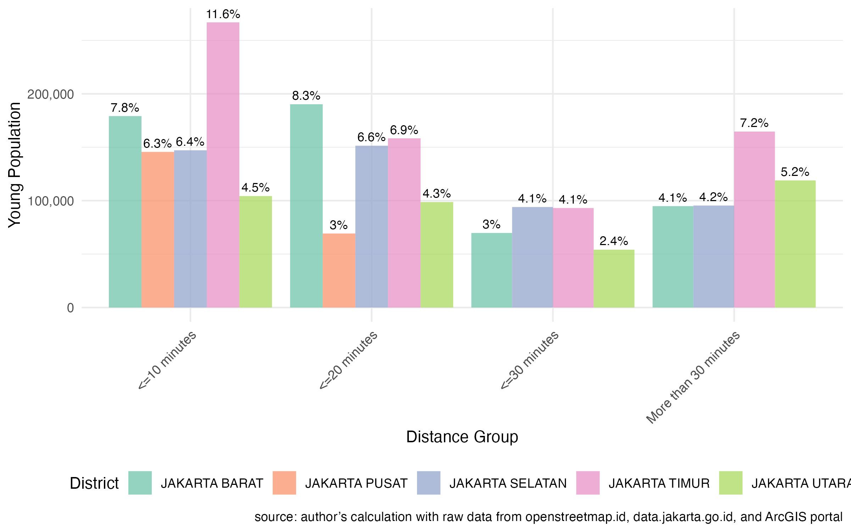

Figure Distribution of Young Population by Distance Group in Every District

**Technical Appendix**

**Data Sources**

The spatial datasets used in this analysis include:

* Open Street Map, “Infrastruktur DKI Jakarta”, 2017, <https://openstreetmap.or.id/en/dki-jakarta/>

This dataset contains information about public facilities located in Jakarta Province, with each point representing one facility.

* Lapak GIS, “Shapefile Jalur-Koridor Busway TransJakarta”, 2018, <https://www.lapakgis.com/2019/04/shp-shapefile-jalur-koridor-busway-transjakarta-gis.html>

This dataset contains information about bus stop and route of Bus Rapid Transfer operating in Jakarta run by TransJakarta.

* Jakarta Open Data, “Jumlah Penduduk DKI Jakarta Berdasarkan Kelompok Usia per Kelurahan”, 2019, <https://data.jakarta.go.id/dataset/data-jumlah-penduduk-provinsi-dki-jakarta-berdasarkan-kelompok-usia-per-kelurahan>

This CSV contains information about population for each age group for every Kelurahan in Jakarta province.

* ArcGIS Portal, “DKI Jakarta Boundary”

This dataset contains information about DKI Jakarta administration boundary until Kelurahan level.

**Description of Technical Process**

Jakarta's public infrastructure data contains all public infrastructure within the boundaries of Jakarta province. When importing this data into ArcGIS, a definition query is required to only select school location. This is achieved by choosing "school" in the "amenity" column. *TransJakarta* shapefile is quite straightforward since it only contains bus stop data*.* *TransJakarta* is a publicly owned company operates in Bus Rapid Transit in Jakarta and surrounding area of Greater Jakarta metropolitan area. Subsequently, the Near Analysis tool is used, with school locations as the Input Features and bus stops as the Near Features. This tool will add two new columns, one of which contain the distance from each school to the nearest bus stop location in meter, and the resulting data is visualized in Figure 1.

Another essential dataset to download is the boundary of Jakarta at the *kelurahan* level. This dataset encompasses boundaries at the *kelurahan* level (level 5), *kecamatan* (level 4), districy (level 3), and province (level 2). Population data at the *kelurahan* level contains population distribution by age group across *kelurahan*. Initially, the data needs cleaning by summing all columns with age groups below 17 years old, as the focus is on calculating school-age population. Additionally, discrepancies in *kelurahan* names between the population data and the boundary shapefile are addressed manually, as outlined in Table 1.

After the necessary cleaning, the Population data is joined with the Boundary Shapefile using the Add Join tool. The Boundary serves as the Input Table with "*kelurahan*" as the Field, and the Population table as the Join Table with "*nama*_*kelurahan*" as the Field. The result is a shapefile depicting the distribution of population in Jakarta.

The subsequent step involves using Spatial Join tools to intersect the school layer with the Boundary layer, thereby adding a new column in the school layer indicating the kelurahan each school is located in. While visualizing the distribution at the *kelurahan* level is impractical due to their abundance, presenting them by city proves sufficient.

The final step entails using summary statistics to count the number of schools in each *kelurahan*. For streamlined calculation and visualization, this step is performed in R by exporting the school layer into CSV. The approach involves a simple calculation by dividing the population in each *kelurahan* by the count of schools in each *kelurahan*, providing a proxy for the young population served by each school. This information is then used to generate Figure 3.

To ensure visual consistency in terms of theme and color selection, all visualizations are conducted in R. Grouping by distance can be easily achieved in R using the `**ifelse**` function. The specified distance groups include "<= 10 minutes," "<= 20 minutes," "<= 30 minutes," and ">30 minutes," corresponding to distances of <= 833 meters, <= 1667 meters, <= 2500 meters, and other, respectively.

Table Kelurahan name inconsistence needs to be manually fixed.

|  |  |
| --- | --- |
| Name in Boundary Shapefile | Name in Population Data |
| krendang | kerendang |
| balekambang | bale kambang |
| kampung rawa | kampung tengah |
| kramatjati | kramat jati |
| kalibaru | kali baru |
| pinangranti | pinang ranti |
| rawajati | rawa jati |
| jatipulo | jati pulo |
| palmeriam | pal meriam |

**Process Map**

Figure Process Map

1. Moreno-Monroy, A. I., Lovelace, R., & Ramos, F. R. (2018). Public transport and school location impacts on educational inequalities: Insights from São Paulo. *Journal of Transport Geography, 67*, 110-118. https://doi.org/10.1016/j.jtrangeo.2017.08.012
2. Getting a driver's license the legal way proves a steep slope. (2016, May 26). *The Jakarta Post*. https://www.thejakartapost.com/news/2016/05/26/getting-a-drivers-license-the-legal-way-prooves-a-steep-slope.html
3. Lam, L. T. (2003). A neglected risky behavior among children and adolescents: Underage driving and injury in New South Wales, Australia. *Journal of Safety Research, 34*(3), 315-320. https://doi.org/10.1016/S0022-4375(03)00026-4